Preserved Mushroom In SO2
Product Description
Mushrooms contain more than 30% protein, which is much higher than common fruits and vegetables. They also contain vitamins, moderate calcium, iron and other minerals. Also, they contain eight kinds of amino acids, which are essential, but cannot be formed in human body.
Therefore, it enables people to enhance the immune system.

Specification | Whole: 10-15/15-20/20-25/25-30/30-35/35-40/40-50mm
Specification | Slice: 15-40/40-60mm
Quality Level: | Top, secondary etc.
INGREDIENTS | Mushroom, water, salt, citric acid, SO2
Color | Pale yellow color with light brown slats
PPM | +/- 1500
Our factory
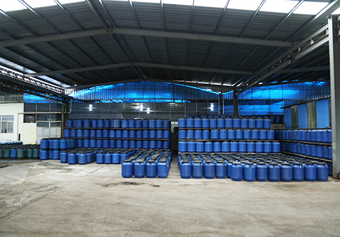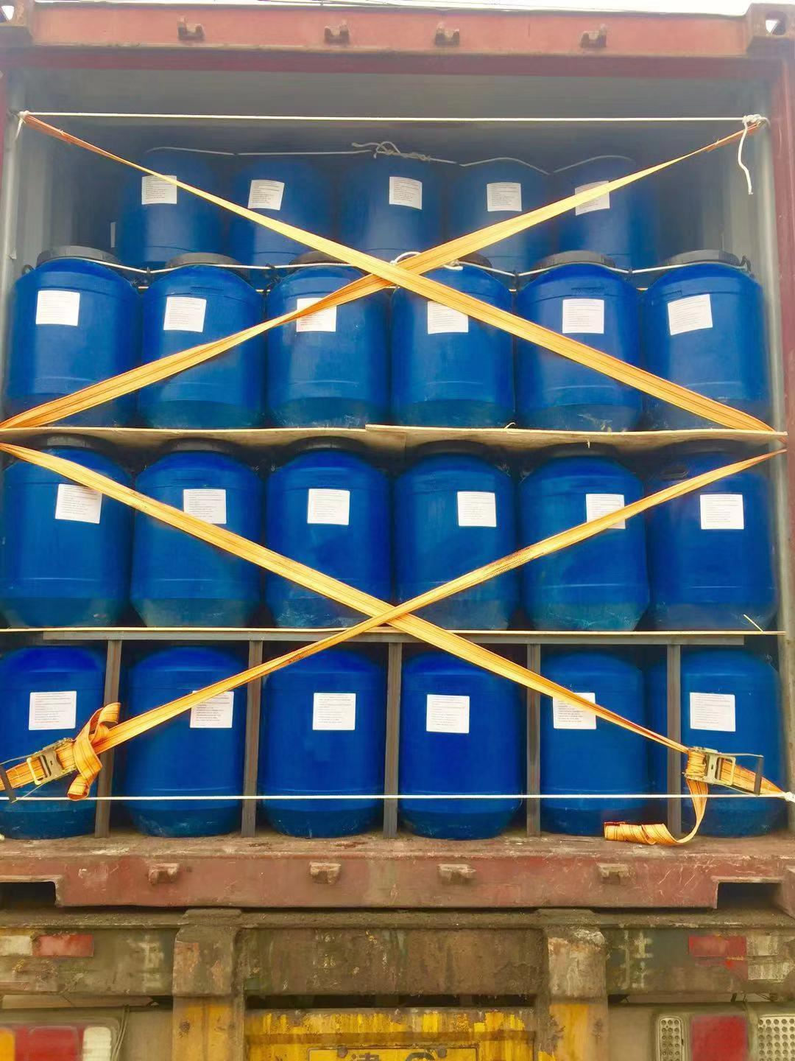

Way to eat
Our products are precooked and ready to eat. No matter in restaurant or your own home, there are several ways to eat:
1)eat directly from the bag.
2)make soup
3)cook dishes with meat or other vegetables.
4)make salad
Our Advantage:
Our mushrooms have high quality and accord with international food standards. It is delicious, healthy and safe.
Mushrooms contain more than 30% protein, which is much higher than common fruits and vegetables. They also contain vitamins, moderate calcium, iron and other minerals. Also, they contain eight kinds of amino acids, which are essential, but cannot be formed in human body.
Therefore, it enables people to enhance the immune system.

